dAn update was made to address issues in Windows where WSL was taking too many resources.
An instruction was added to the Dockerfile to limit how many resources it can take.
Optimizations were also made. Any data or files will not be lost.

This guide is also for subsequent updates

Step 1 Make sure to stop the container first and the delete
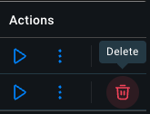

Step 2 Update the dockerfile using the command:
docker pull seancnc/unlv-cs-ide

Step 3 Create the new container:
docker run -it -p 127.0.0.1:8080:8080 -v cs135_data:/home/coder/CS135 seancnc/unlv-cs-ide

